
Year 7

Mini Test 2 – Perimeter and Area

Calculator Allowed.
SHOW YOUR WORKING
NAME:__________ Score: ____ /28
Total time: 30mins

- [4 marks: ½ each]
Complete the following metric conversions.
- 7 cm = mm  - 3 km = m  - 14 m = cm  - 8.4 m = cm | - 9.2 m = cm  - 56 000 mm = m  - 2.1 km = cm  - 6000 cm = km

- [5 marks: 1,1,1,2]
Find the perimeter of the following shapes.
(The distance between the dots is 1cm)
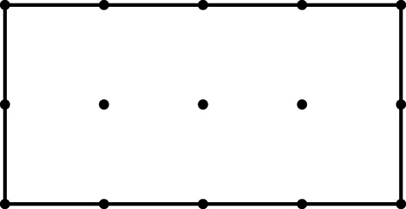 | 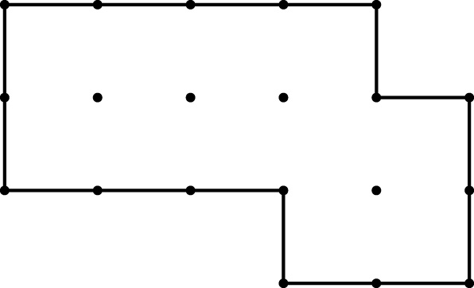
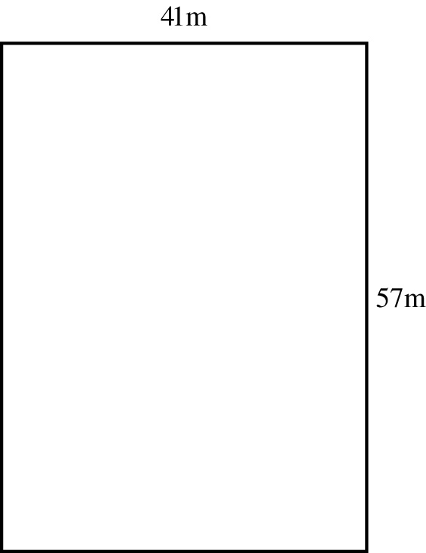 | 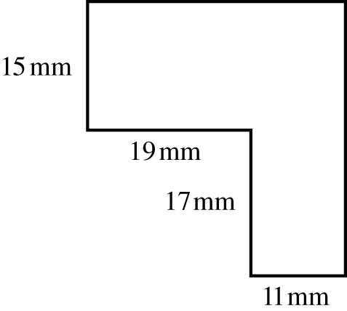

- [2 marks]
Find the area of the following shapes, if each square has an area of 1 cm²
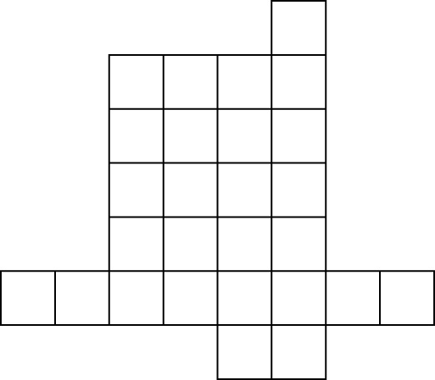 | 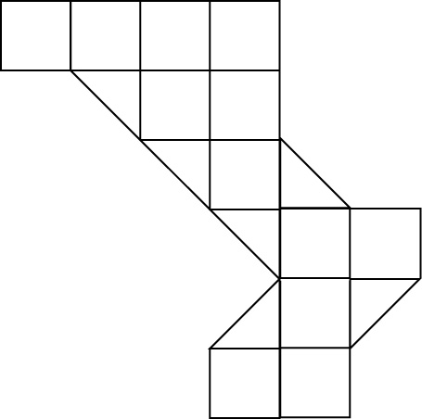

- [11 marks: 2, 2, 2, 2, 3 marks]
Find the area of the following shape
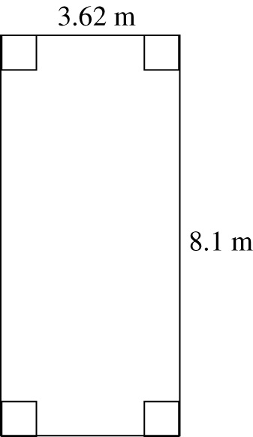 | 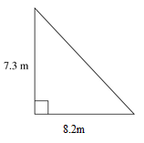

- [3 marks]
A triangle is cut out of a cardboard square.
Find the area of cardboard left using the figure below.
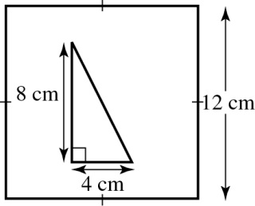

- [3 marks]
Rachel and Nathan are building a deck across the back of their house. A fence will surround the deck and have three horizontal rails all the way around.

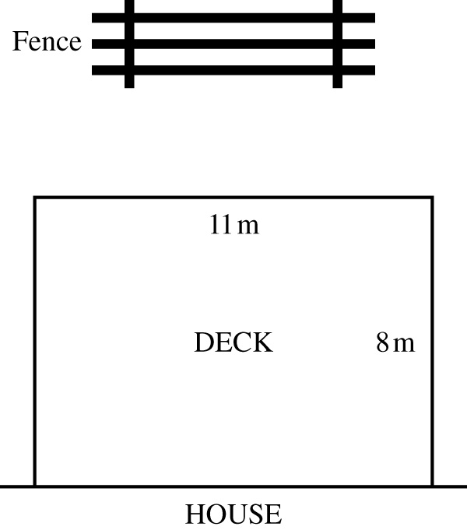

If the deck is 8 m wide and 11 m long, find the total length of wood needed to make the rails of the fence.

END OF TEST

